Project Design Phase-II
Data Flow Diagram & User Stories

Date | 03 October 2023
Team ID | NM2023TMID00044
Project Name | Project - Quantitative Analysis of Candidates in 2019 Lok Sabha Elections
Maximum Marks | 4 Marks

Data Flow Diagrams:

A data flow diagram (DFD) in the context of Cognos refers to the visualization of how data moves through the platform. It showcases the processes involved, such as data extraction, transformation, and loading (ETL), as well as the interactions with various data sources and destinations. This diagram provides a clear and structured representation of how Cognos connects to different data repositories, performs data preparation and transformation tasks through features like data flows, and ultimately generates visualizations. It helps users understand the flow of information within Cognos, facilitating effective data analysis and visualization

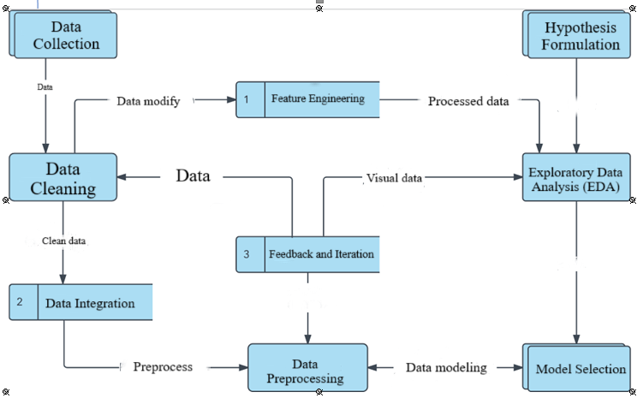
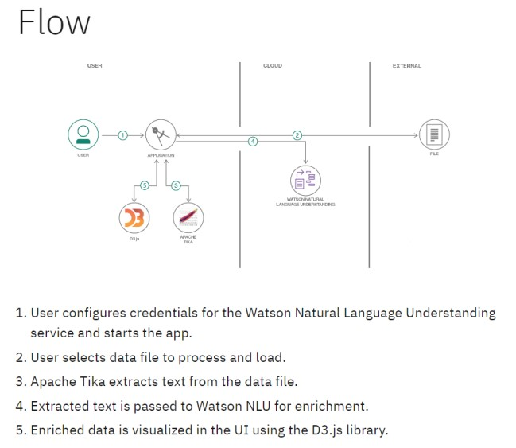

User Stories
Use the below template to list all the user stories for the product.
User Type | Functional  Requirement (Epic) | User Story  Number | User Story / Task | Acceptance criteria | Priority | Release
Customer  (Mobile user) | Registration | USN-1 | As a user, I can register for the application by entering my email, password, and confirming my password. | I can access my account / dashboard | High | Sprint-1
 |  | USN-2 | As a user, I will receive confirmation email once I have registered for the application | I can receive confirmation email & click confirm | High | Sprint-1
 |  | USN-3 | As a user, I can register for the application through Facebook | I can register & access the dashboard with Facebook Login | Low | Sprint-2
 |  | USN-4 | As a user, I can register for the application through Gmail |  | Medium | Sprint-1
 | Login | USN-5 | As a user, I can log into the application by entering email & password |  | High | Sprint-1
 | Dashboard | USN-6 | Dashboard provide needed information for the user
Customer (Web user) | Cognos | USN-7 | Cognos work links display in web application directly access for the user

